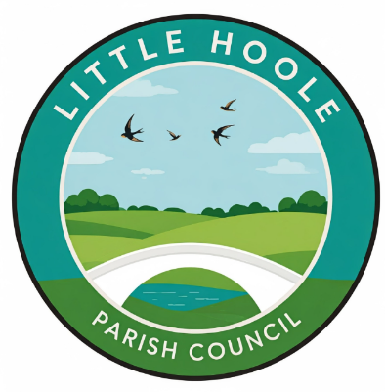AGENDA - Annual Meeting of Little Hoole Parish Council
Members of the Council are Summoned to the Annual Meeting of the Parish Council to be held on Mon 11th May 2026 at 18.45pm,
The Lounge, Walmer Bridge Village Hall, Gill Lane, Walmer Bridge
Paul Cafferkey, Clerk & Responsible Financial Officer

- Election of Chair
- Election of Vice Chair
- Apologies for absence
- Minutes of the Previous Annual Meeting of the Parish Council
- Report from Cllr Dryden (as the Chair for 2025/26) on the past year
- Public Time: to invite and listen to issues raised by members of the public
- To resolve to review at future meetings in the coming year: Standing Orders, Financial Regulations, Risk Management Policy, Fixed Asset Register, Insurance Arrangements, Code of Conduct; and any other policies considered necessary.
This Annual Meeting of the Parish Council will be immediately followed by the May 2026 Parish Council Meeting at approx. 19:15 – please see separate agenda.

Members of the public are welcome to attend meetings to raise any relevant matters.
Alternatively, if you cannot attend the meeting but wish to raise a matter or ask a question, this can be done on your behalf by contacting the Parish Clerk (Paul Cafferkey) via email at clerk@littlehoole-pc.gov.uk or mobile phone 07966267186.

Go to the Little Hoole Parish Council Website
https://www.littlehoole-pc.gov.uk

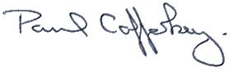
Prepared and approved by Paul Cafferkey, Clerk – Little Hoole Parish Council,
6th May 2026

